NETWORK INVESTIGATION
11. IP address check karo
Ipconfig
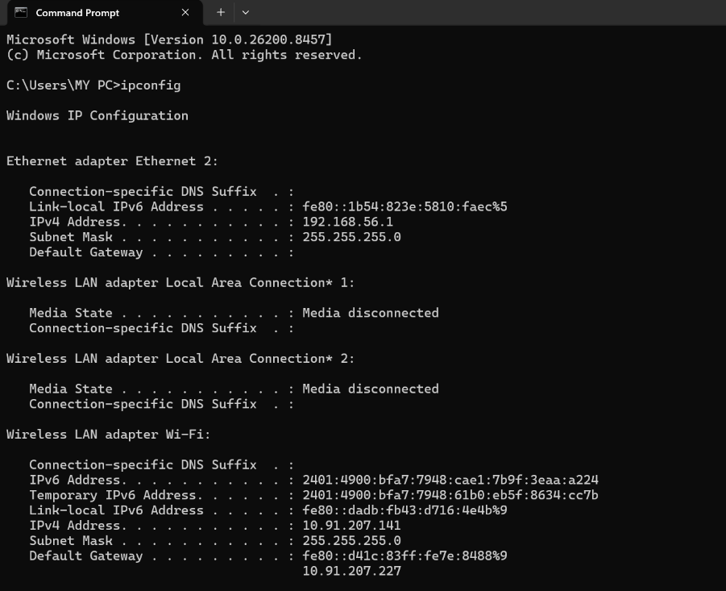
SOC POV
Host identification.
- Ipv4 – yeh hota hai device ka unque id
- Ipv6 – yeh bhi ek unquie hi id hoti hai
- Ethernet adapter ethernet 2 – virtual network hota hai aggar app vmware use karte ho
- Unkown adapter macfee vpn – yhe tab hota jab apke laptiop mai mac fee install ho yeh create karta hai sercret tunne
- Wireless lan adapter local area connection1- mobine hotspot ya blutooth k liye
- Wireless lan adapter primary – yeh apka actual wifi connection
- Default address – router ki ip

12. Detailed network info
ipconfig /all
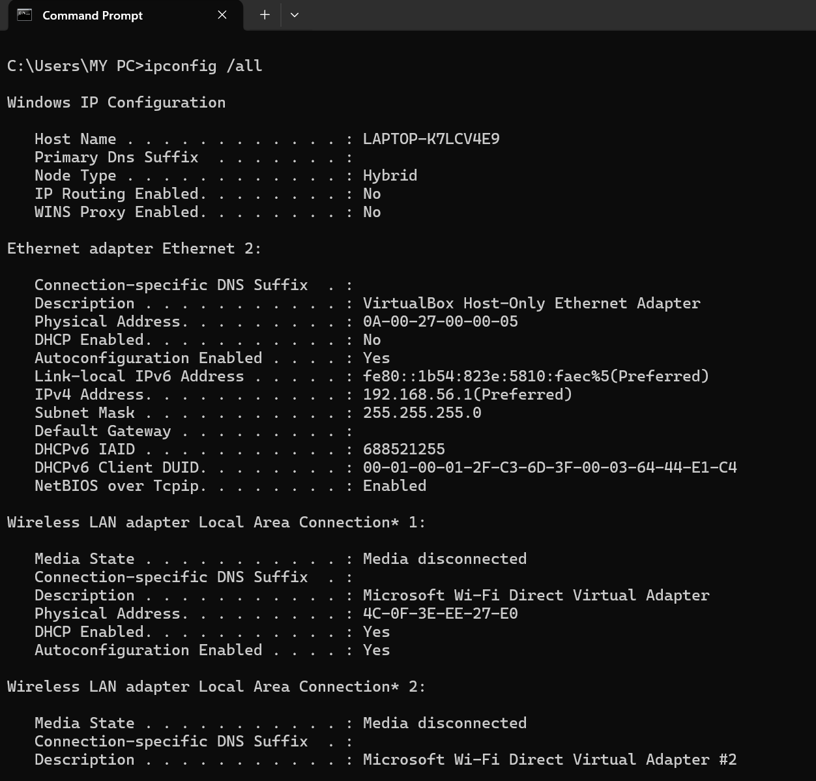
SOC POV
DHCP, DNS investigation.
- Ip routing – means computer ac as router
- Wins proxy – used to help compuetrs to find each others
- Physical address- mac address
- Dhcp enable – your system get ip address automatically y don’t have to enter the ip manually
- Dhcp server – router ip address= gateway address
- Lease obtaine and lease expire= as your router borrow ip address for shoert period of time so thse are dated u can use it

13. Active connections dekho
netstat -ano
SOC POV
Malware C2 connection detect
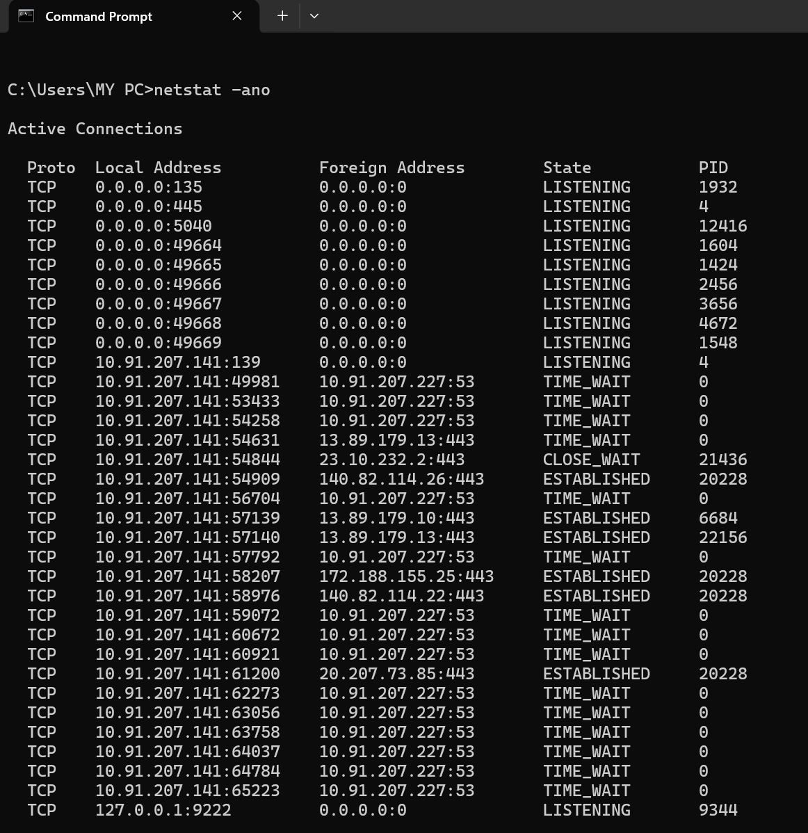

- Listening- computer is waiting for data
- Establishment- connection is in process
- Time wait – connection is closed but computer is waiting for delayed packet before port fully released
Detect suspicious –
- If find unfamiliar foreghn ip
- High used ports indicate backdoors
- Unexpected establishment – like if not any app open
- High port can be used by src ip cause it want return asddress for data so it uses high ports
- But ds tip cannot use high port as it can be malicious
- Foreign ip last number port hota hai

14. Specific port search karo
netstat -ano | findstr 443
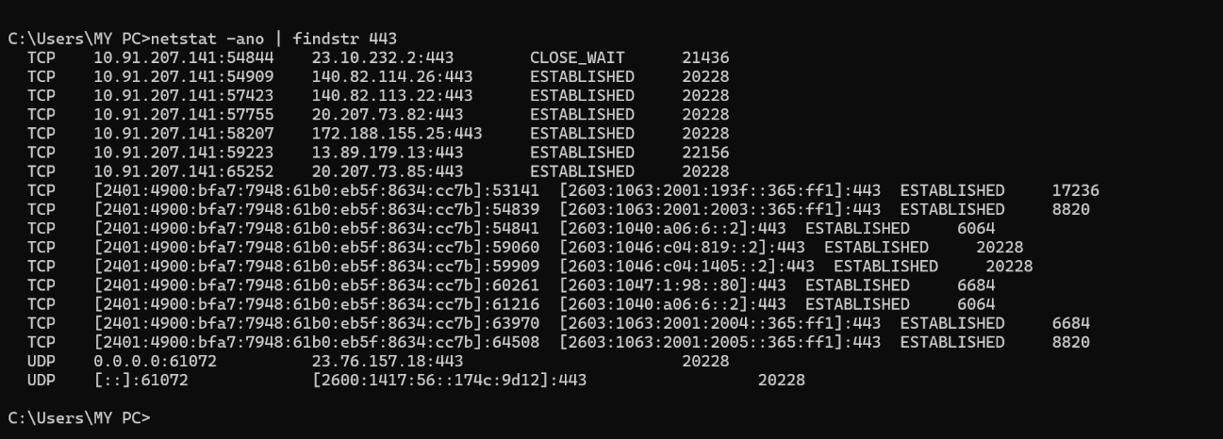
if you want ot find which app is making outbound calls then command
netstat -abno | findstr 44 (it will agve output in only run as administrator )
SOC POV
Suspicious outbound traffic.(by lookingat foreign ip )

15. Process ID identify karo
tasklist | findstr PID
SOC POV
Network connection kis process ne open kiya.

16. ARP table dekho
arp -a
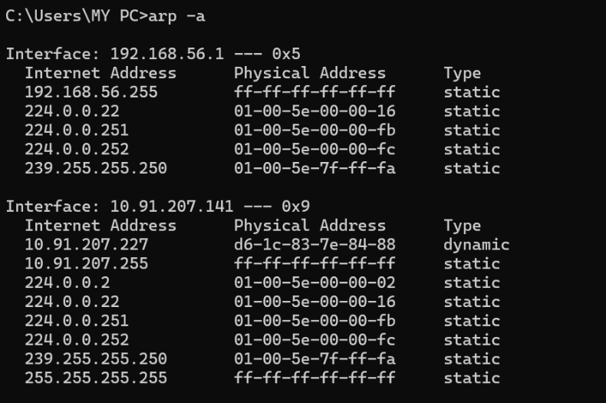
SOC POV
ARP spoofing detect.
- Interface – ip address of the device to which arp table display
- Dynamic means entry automatically learn when device communicate with each other, these entries expire if not use in few minutes
- Static – entries enter manually and not expire like dynamic
- same mac address of diffremt ip - suspicious

17. DNS cache check karo
ipconfig /displaydns
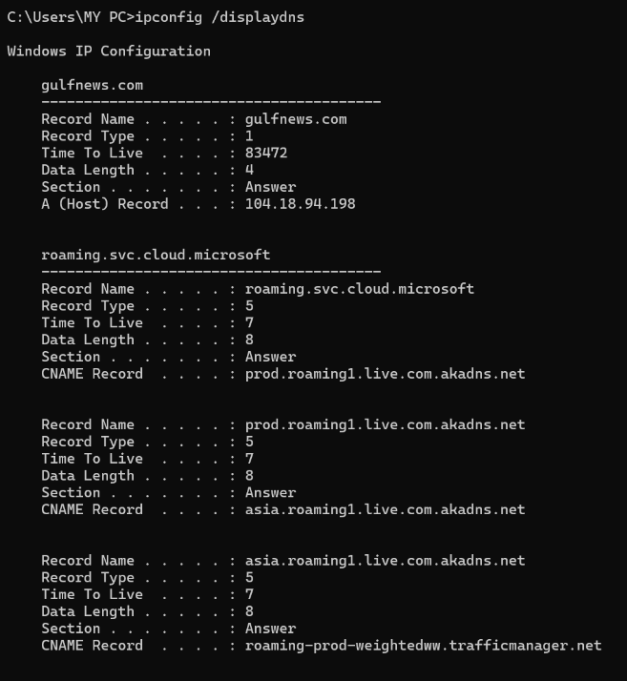
SOC POV
Malicious domain lookup.
- Suspicious domain like – xyz.com, gOOgle.com
- Ttl- specific time in seconds that show how much time enrteis remain in cache before dns referesh it

18. DNS cache clear karo
ipconfig /flushdns
SOC POV
Poisoned DNS remove.
- We don’t have to remove dns cahe cuse it is a gold for investigation
- But if we clear it its for technical flix like fix error , to maintain privacy
- And yes it will clear all entries not only suspicious one

19. Network share list karo
net share
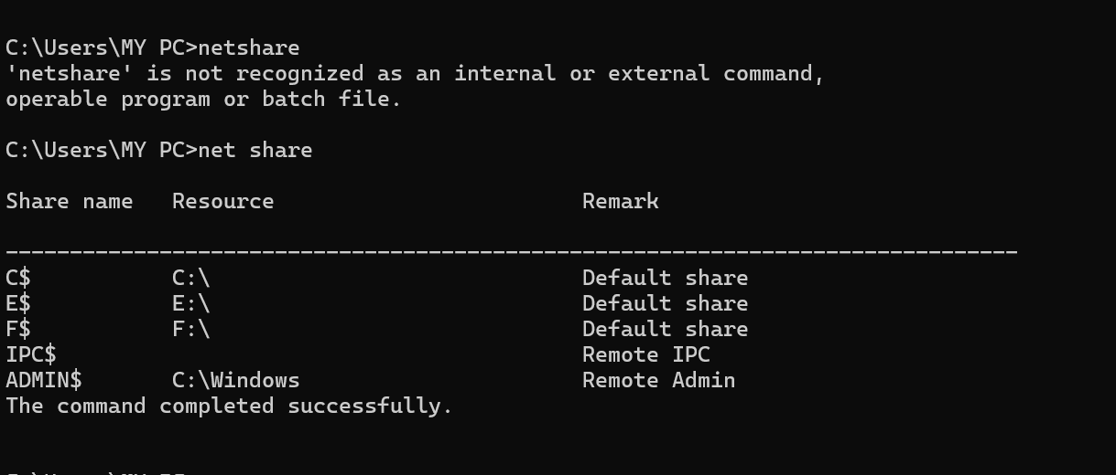
SOC POV
Unauthorized sharing.
- Share name- forlder or drive so that others computers can find in on network
- $- something end with dollars means it hidden
- Default share – it is folder automatically assigned by computer for administration purpose
- Remote admin- basically window folder for mantanence
- Remote ipc – folder for communication between two programs
- If u find suspicious one you have tio run command promp as administrator and run net session to seek active connection if somne look your share files
- Net file – for see whch file is open

20. Remote sessions check karo
query user
SOC POV
Unauthorized login.
- App yeh use nahi kar sakte kyuki yeh ek pro feature hai jo personal lapyop pe ni hota kyuki yeh files nahi hoti usually personal computer pe yeh basically badhi organization mai hoti hai

